**Assignment 3**

**Question 1 (Load a flat file)– CODE**

!pip install pymysql

!pip install mysql

!pip install MySQL-python

#importing the csv file from local computer

import pandas as pd

data = pd.read_csv("D:/my company/loss iland/DOB_Job_Application_Filings.csv")

#selcting only rows which are required

data1 = data[['Job #', 'Doc #', 'Borough', 'House #', 'Street Name','Job Type', 'Job Status', 'Job Status Descrp','Latest Action Date']]

data1['Job #'].unique() #Checking the unique types in "Job #"

data1['test'] =data1['Job #'].str.isnumeric()

data1[data1['test'] == False] # here we can find the incorrct datatype in Column Job - we will delete this rows from our table

data1 = data1[data1['test'] != False] # removing the noise in the Job #

data2 = data1.drop(['test'],axis=1).head(100)

data2['Job #'] = data2['Job #'].astype(int) #converting Job # into integer type

data2['Latest Action Date'] = data2['Latest Action Date'].apply(pd.to_datetime) #converting Date in date type

cols = "`,`".join([str(i) for i in data2.columns.tolist()])

data2 = data2.reset_index(drop=True)

import pymysql

connection = pymysql.connect(host = '34.123.84.120',

user = 'root',

db = 'hw3',

password = 'NO',

cursorclass = pymysql.cursors.DictCursor)

print(connection)

cursor = connection.cursor()

sql1 = "Create table if not exists Job5 (Job int,Doc float,Borough varchar(255),House_No varchar(255),Street_name varchar(255),Job_type varchar(255),Job_status varchar(255), Job_Status_Descrp varchar(255),Latest_Action_Date date )"

cursor.execute(sql1)

# Insert DataFrame recrds one by one.

for i,row in data2.iterrows():

sql = "INSERT INTO `Job5` VALUES (" + "%s,"*(len(row)-1) + "%s)"

cursor.execute(sql, tuple(row))

# the connection is not autocommitted by default, so we must commit to save our changes

connection.commit()

connection.close()

**OUTPUT OF VM for Question -1**

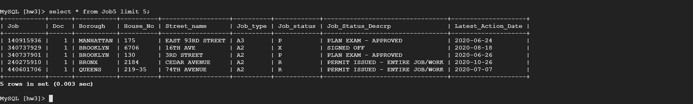

**Question(load CSV data from an API) -2:**

import requests

import pandas as pd

url = "https://data.cityofnewyork.us/resource/ic3t-wcy2.csv"

req = requests. get(url)

url_content = req. content

csv_file = open('downloaded.csv','wb')

csv_file. write(url_content)

csv_file. close()

data = pd.read_csv('downloaded.csv')

#selcting only rows which are required

data1 = data[['job__', 'doc__', 'borough', 'house__', 'street_name','job_type', 'job_status', 'job_status_descrp','latest_action_date']]

data2 = data1.head(100)

data2 = data2.reset_index(drop=True)

import pymysql

connection = pymysql.connect(host = '34.123.84.120',

user = 'root',

db = 'hw3',

password = 'NO',

cursorclass = pymysql.cursors.DictCursor)

print(connection)

cursor = connection.cursor()

sql1 = "Create table if not exists Job_api1 (Job int,Doc float,Borough varchar(255),House_No varchar(255),Street_name varchar(255),Job_type varchar(255),Job_status varchar(255), Job_Status_Descrp varchar(255),Latest_Action_Date date )"

cursor.execute(sql1)

# Insert DataFrame recrds one by one.

for i,row in data2.iterrows():

sql = "INSERT INTO `Job_api1` VALUES (" + "%s,"*(len(row)-1) + "%s)"

cursor.execute(sql, tuple(row))

# the connection is not autocommitted by default, so we must commit to save our changes

connection.commit()

connection.close()

**Question 2 output I on VM:**

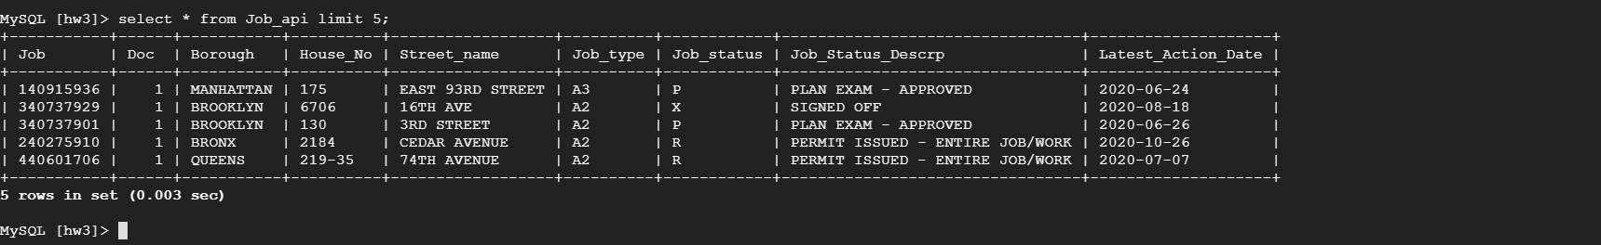

**Question 3 (Clean data, Then load data) :**

import requests

url = "https://data.cityofnewyork.us/resource/ic3t-wcy2.csv"

req = requests. get(url)

url_content = req. content

csv_file = open('downloaded.csv','wb')

csv_file. write(url_content)

csv_file. close()

data = pd.read_csv('downloaded.csv')

#selcting only rows which are required

data1 = data[['job__', 'doc__', 'borough', 'house__', 'street_name','job_type', 'job_status', 'job_status_descrp','landmarked','adult_estab','latest_action_date','existing_occupancy', 'proposed_occupancy','owner_type','job_description','initial_cost' ]]

data1 = data1.dropna(subset = ['landmarked','adult_estab','job_description']).reset_index()

data1['initial_cost'] = data1['initial_cost'].str.replace('$','').astype(float)/10000

data1['latest_action_date'] = data1['latest_action_date'].apply(pd.to_datetime) #converting Date in date type

data1 = data1.drop('index',axis=1)

import pymysql

connection = pymysql.connect(host = '34.123.84.120',

user = 'root',

db = 'hw3',

password = 'NO',

cursorclass = pymysql.cursors.DictCursor)

print(connection)

cursor = connection.cursor()

sql1 = """Create table if not exists Job_cl (Job int,Doc int,Borough varchar(255),House_No varchar(255),

Street_name varchar(255),Job_type varchar(255),Job_status varchar(255), Job_Status_Descrp varchar(255),

landmarked varchar(255), adult_estab varchar(255) , Latest_Action_Date date ,existing_occupancy varchar(255),

proposed_occupancy varchar(255),owner_type varchar(255) ,job_description varchar(255),initial_cost float )"""

cursor.execute(sql1)

# Insert DataFrame recrds one by one.

for i,row in data1.iterrows():

sql = "INSERT INTO `Job_cl` VALUES (" + "%s,"*(len(row)-1) + "%s)"

cursor.execute(sql, tuple(row))

# the connection is not autocommitted by default, so we must commit to save our changes

connection.commit()

connection.close()

